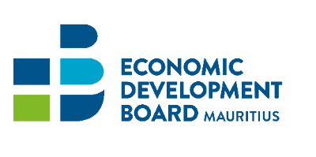

ICT/BPO Scheme for Rodrigues
Enrolment Form
Name of Company | :
Annual Turnover (MUR)  [As per last Audited Financial Statement] | :
Business Registration Number (BRN) | :
VAT No. / TAN No. | :
Authorisation Letter from Commission for Trade, Commerce, & Licensing | :
Registered Office Address | :
Contact Person | :
Designation | :
Telephone/Mobile | :
Fax | :
Email | :
Website | :
Business activity | :
Product(s)/Services | :
Date: …………………………………. |  | Signature: ……………………………………………….
Company Seal |  | Designation: …………………………………………….

False or Misleading Declaration

- It is an offence under section 39 (2) of the Economic Development Board Act, for a person to give information, particulars, or documents or to make any statement which is false or misleading in any material particular. On conviction, an offender shall be liable to a fine not exceeding 500,000 rupees and to imprisonment for a term not exceeding 5 years.
- In addition, notwithstanding any other action that the EDB may choose to take, in case of a false or misleading declaration:
a. The applicant will not be eligible for any future rebate under any Scheme administered by the EDB, and
b. The applicant shall be liable to refund any amount obtained under the Scheme.

