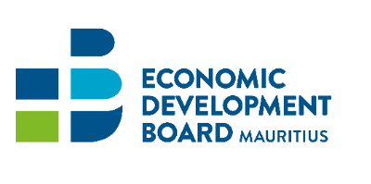
Enrolment Form-Incentives for Exports
Name of Company | :
Annual Turnover (MUR)  [As per last Audited Financial Statement] | :
Business Registration Number (BRN) | :
Export Development Certificate (EDC) No. | :
VAT /TAN No. | :
Address | :
Contact Person | :
Designation | :
Telephone/Mobile | :
Fax | :
Email | :
Website | :
Product(s) manufactured in Mauritius | :
Export product(s) and HS Code(s) | :
Export Market(s) | :
Date: …………………………………. |  | Signature: ……………………………………………….
Company Seal |  | Designation: …………………………………………….
The one-off enrolment with the EDB is valid for the following incentives:
(a) Freight Rebate Scheme (Exports by Sea)
(b)Trade Promotion & Marketing Scheme (Exports by Air)
(c) Export Credit Guarantee Insurance Scheme
False or Misleading Declaration
- It is an offence under section 39 (2) of the Economic Development Board Act, for a person to give information, particulars, or documents or to make any statement which is false or misleading in any material particular. On conviction, an offender shall be liable to a fine not exceeding MUR 500,000. and to imprisonment for a term not exceeding 5 years.
- In addition, notwithstanding any other action that the EDB may choose to take, in case of a false or misleading declaration:
a. The applicant will not be eligible for any future rebate under any Scheme administered by the EDB, and
b. The applicant shall be liable to refund any amount obtained under the Scheme.

